Wireframes and Mockups

Prof. Leete

Oct 22, 2016

Web Project Management

Team 1 – Dalaney, Robert s, Robert G, Colleen

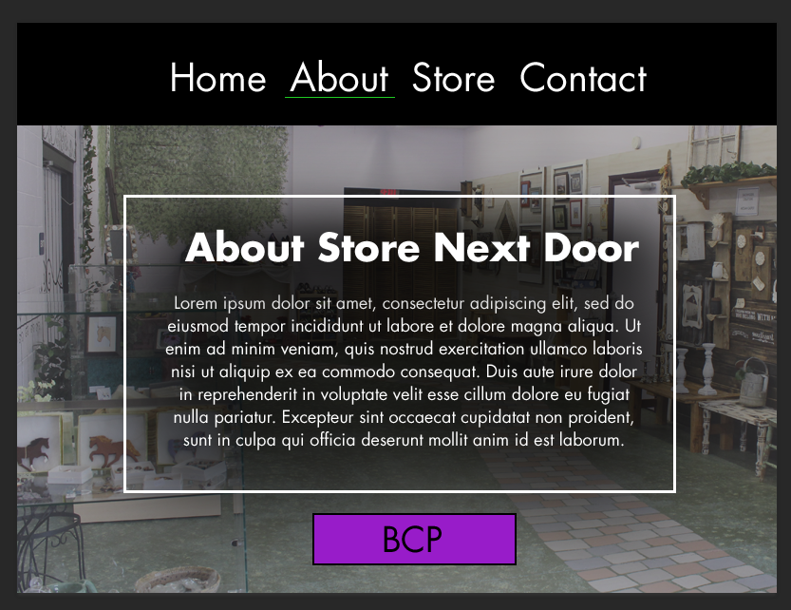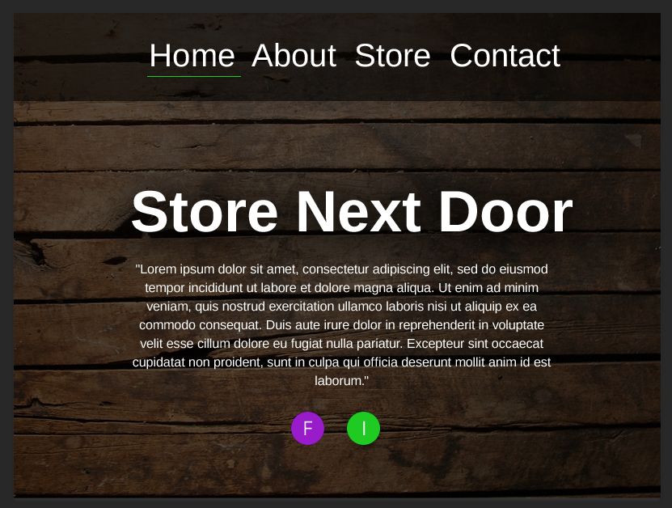

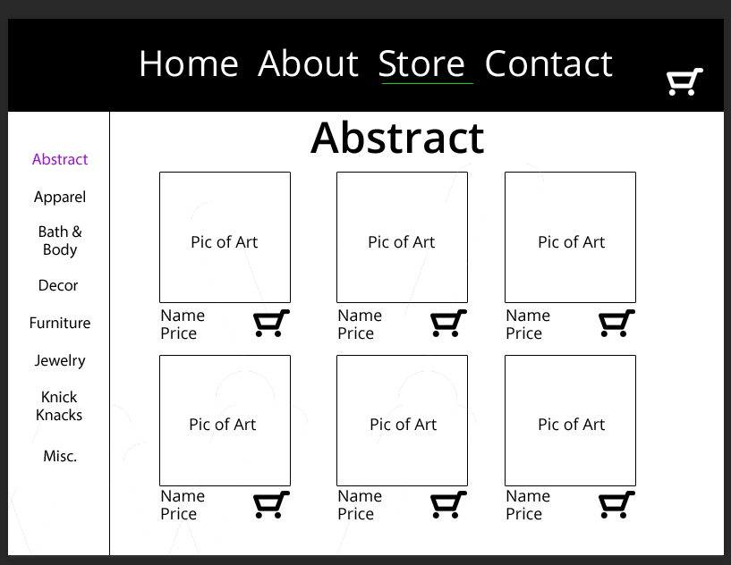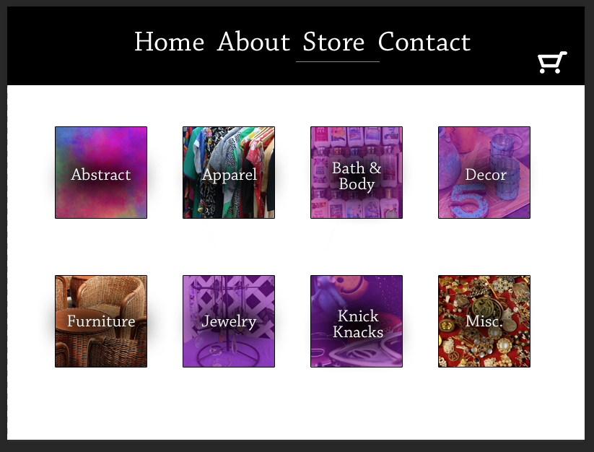

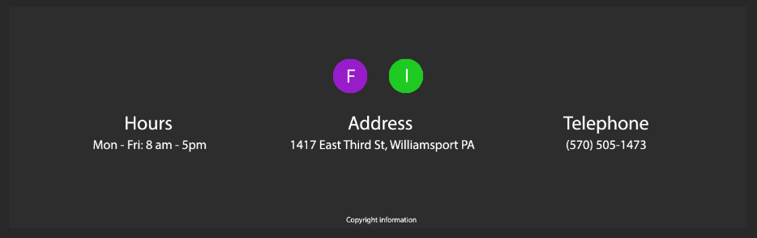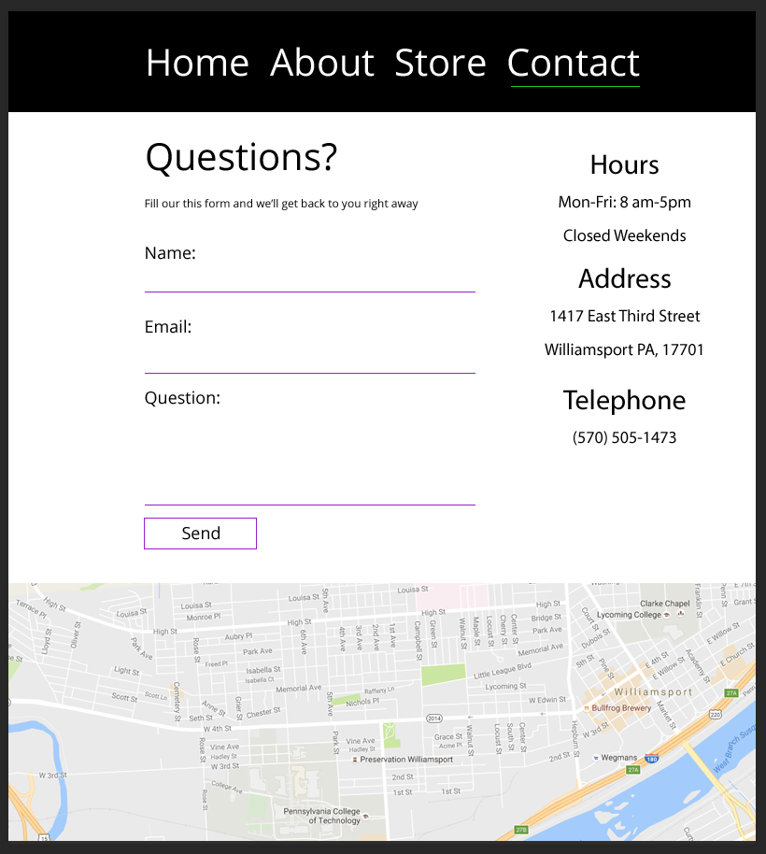

Here are the mockups. We wanted a simple design that is also modern. We wanted to make it simple since the photos will be the “star” of the show, meaning that they need the most attention. The home page is plain and simple with a simple saying, no more than 140 characters. The mock up is a little much. The about page just talks about Store Next Door and a sentence or two relating to Beckoning Cat Project, with a link to their actual website at the bottom. The category page categorizes the artist’s work into what they actually are. Then the sub category page shows the actual work under those main categories. We have a contact page with simple information and then a footer that will go across all pages.

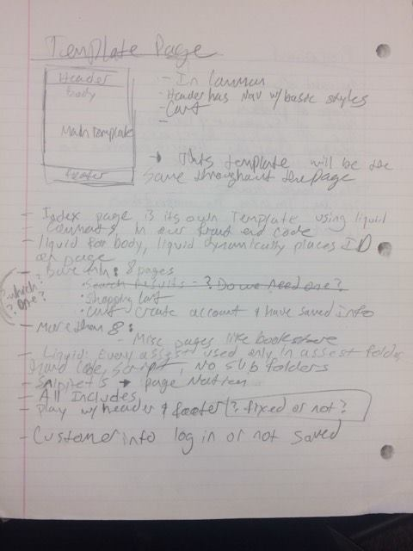Wireframes:

